Technical Requirements Mall Insight
L1 Dashboard KPIs and Behavioral Segment Movement
1. Core L1 KPI Definitions
These calculations evaluate the value and penetration of members shopping at both companies in the same visit.
- Dual Members: The total count of distinct members who have $≥1$ transaction at AVN and $≥1$ transaction at AMV within the same-day session.
  - countIf(Company='AVN') > 0 AND countIf(Company='AMV') > 0
- Dual-Shopper Rate: Percentage of the total purchasing member base that qualifies as Dual Members.
$$\text{Dual-Shopper Rate}=\left(\frac{\text{Dual Members}}{\text{Total Purchasing Members}}\right)×100\%$$
- Dual Spend Share (%): Compares the average spend of a dual shopper against the average spend of all purchasing members.
$$\text{Dual Spend Share}=\left(\frac{\text{Avg Spend per Dual Member}}{\text{Avg Spend per Total Purchasing Member}}\right)×100\%$$
- Incremental Spend (%): The percentage increase in average spend of dual shoppers compared to single-company shoppers.
$$\text{Incremental Spend}=\left(\frac{{\text{Avg Spend}}_{\text{Dual}}-{\text{Avg Spend}}_{\text{Single}}}{{\text{Avg Spend}}_{\text{Single}}}\right)×100\%$$
2. Behavioral Segment Conditions
- Single-Mall: Members who exclusively generated transactions at exactly one mall during the evaluated period.
  - uniqExact(Mall_ID) = 1
- Single-Visit: Members who visited the mall for exactly one day during the period, meaning their Average Frequency/Visit Depth is 1.
  - uniqExact(toDate(Transaction_DT)) = 1
3. Key Movement Logic (Single-Mall)
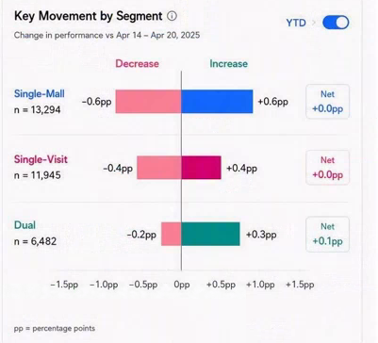
The Divergent Bar Chart measures the net migration of members into and out of the Single-Mall segment compared to the previous period. Note that "Total Purchasing Members" corresponds to the metric 1.11a base.
Movement Type | Business Logic | Formula (Percentage Points)
Increase (+pp) (Blue) | Members newly joining the Single-Mall segment.( Members who were not in the Single-Mall segment in the previous period but are in the current period.) | $$\left(\frac{\text{Count}\left(\text{Curr}=1\text{ Mall}\text{ and }\text{Prev}≠1\text{ Mall}\right)}{{\text{Total Purchasing Members}}_{\text{Curr}}}\right)×100$$
Decrease (-pp) (Pink) | Members abandoning the Single-Mall segment.( Members who left the Single-Mall segment in the current period.) | $$\left(\frac{\text{Count}\left(\text{Prev}=1\text{ Mal}\text{l and }\text{Curr}≠1\text{ Mall}\right)}{{\text{Total Purchasing Members}}_{\text{Prev}}}\right)×100$$
Net | The absolute net percentage point change. | $$\text{Increase}+\text{Decrease}$$
4. ClickHouse SQL Implementation
SQL
WITH
-- 1. Identify unique Malls visited by each Member per period
member_stat AS (
SELECT
Member_ID,
uniqExactIf(Mall_ID, Transaction_DT BETWEEN {prev_start} AND {prev_end}) AS prev_malls,
uniqExactIf(Mall_ID, Transaction_DT BETWEEN {curr_start} AND {curr_end}) AS curr_malls
FROM TB_Member_Consumption
WHERE IsDelete = 0
AND Transaction_DT BETWEEN {prev_start} AND {curr_end}
GROUP BY Member_ID
HAVING prev_malls > 0 OR curr_malls > 0
),
-- 2. Establish Total Purchasing Members denominators[cite: 1]
totals AS (
SELECT
countIf(prev_malls > 0) AS total_prev,
countIf(curr_malls > 0) AS total_curr
FROM member_stat
)
SELECT
'Single-Mall' AS segment,
countIf(curr_malls = 1) AS n,
-- Increase (+pp)
round(countIf(curr_malls = 1 AND prev_malls != 1) * 100.0 / any(total_curr), 1) AS increase_pp,
-- Decrease (-pp)
-round(countIf(prev_malls = 1 AND curr_malls != 1) * 100.0 / any(total_prev), 1) AS decrease_pp,
-- Net Change (pp)
round(increase_pp + decrease_pp, 1) AS net_pp
FROM member_stat, totals;

L2 Characteristics – Shopper Behavior
- Spend Change After Starting Dual Usage
The "Spend Change After Starting Dual Usage" cohort trend chart tracks the cumulative percentage change in a customer's total spend relative to their personal baseline following their first dual-company visit. Below is the business logic and a concrete example for BI Developers to implement this directly.
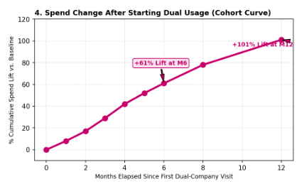
1. Core Calculation Logic (Cohort Math)
- Identify Month T0 (Activation): The system scans the transaction history to pinpoint the first month (Month 0) where a customer generates $≥1$ transaction at AVN and $≥1$ transaction at AMV within a same-day session.
- Calculate the Baseline: Retrieve the customer's total spend during the 3 months immediately prior to their first dual usage, then divide by 3 to establish their average monthly spend before conversion.
- Calculate Cumulative Spend (Y-axis): For each month $Tn$ (from 0 to 12) following activation, calculate the customer's cumulative average monthly spend (total spend from T0 to $Tn$ divided by the number of elapsed months). Next, calculate the percentage variance of this cumulative average against the Baseline.
- X-axis (Relative Time): Standardize all customers to a shared starting line spanning 0 to 12 months from their personal T0, disregarding actual calendar months. The final chart aggregates and displays the average percentage change across all customers at each monthly milestone.
2. Implementation Example
Assume User A makes their first dual-usage purchase in September (T0).
Cohort Milestone | Actual Calendar Month | Actual Total Spend | Cumulative Average Spend (T0 to Tn) | Growth Rate (Y-axis)
Baseline (3 Months) | June, July, Aug | 1.0M, 1.5M, 0.5M | 1.0M (Avg. 3 months prior to T0) | -
Month 0 (T0) | September | 1.08M | 1.08M / 1 month = 1.08M | (1.08 - 1.0) / 1.0 = +8%
Month 1 (T1) | October | 1.26M | (1.08M + 1.26M) / 2 = 1.17M | (1.17 - 1.0) / 1.0 = +17%
Month 2 (T2) | November | 1.53M | (1.08M + 1.26M + 1.53M) / 3 = 1.29M | (1.29 - 1.0) / 1.0 = +29%
3. Data Prep Notes for BI Developers
BI engineers must generate a Derived Table to assign a cohort_month = 0 flag for each Member_ID based on the date of their first dual transaction. Subsequent transactions are evaluated based on the elapsed month gap (months_between) from the cohort_month. If a customer generates no purchases in any specific month post-T0, the spend for that month is recorded as 0, but the denominator (cumulative months) must still increment to ensure the average value remains mathematically accurate.
- Monthly Visit Days
The Monthly Visit Days Distribution chart belongs to the L2 (Analysis) layer, categorizing shoppers by the number of days they visit the mall per month to directly compare frequency patterns between dual-company shoppers and single-company shoppers.
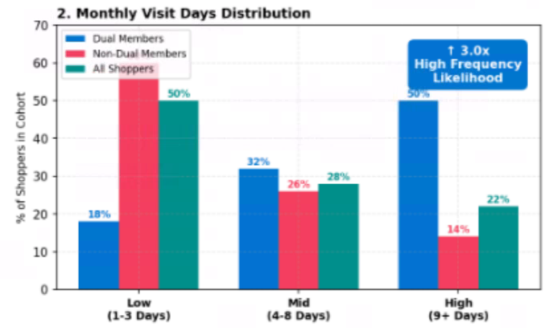
1. Cohort Targeting Logic
- Dual Members (Blue): Members who generate at least one transaction at AVN and at least one transaction at AMV within the same-day session.
- Non-Dual Members (Pink/Red): Members who generate transactions at only one company (either AVN or AMV) during the evaluated period.
- All Shoppers (Teal/Green): The average distribution baseline of all members with valid purchasing transactions at the mall.
2. Calculation Mechanism (Metrics & Dimensions)
- X-axis (Frequency Tiers): The system counts the distinct visit days for each individual customer within the month. Shoppers are then categorized into three fixed tiers: Low (1-3 days), Mid (4-8 days), and High (9+ days).
- Y-axis (% of Shoppers): Measures the percentage of members falling into each frequency tier, calculated against the total size of that specific cohort. The sum of the three columns belonging to the same color/cohort (Low + Mid + High) will always equal 100%.
- Dynamic Callout(If posible or it should behind the chart): The 3.0x multiplier is derived by dividing the percentage of High-frequency Dual Members by the percentage of High-frequency Non-Dual Members. This metric proves that dual shoppers are 3.0 times more likely to become High Frequency visitors compared to single-company shoppers.
3. Mathematical Example
Assume the system records a total of 1,000 Dual Members in a given reporting month.
Frequency Tier (X-axis) | Actual Customer Count | Y-axis Calculation Formula | Chart Display
Low (1-3 Days) | 180 customers visiting 1 to 3 days | (180 / 1000) * 100% | Blue column at 18%
Mid (4-8 Days) | 320 customers visiting 4 to 8 days | (320 / 1000) * 100% | Blue column at 32%
High (9+ Days) | 500 customers visiting 9 or more days | (500 / 1000) * 100% | Blue column at 50%

- Weekly spending distribution
- p25_weekly_spend: 278,691.5 VNĐ
- p50_weekly_spend (Median): 558,122.38 VNĐ
- p75_weekly_spend: 1,037,218.4 VNĐ
- p90_weekly_spend: 1,781,619.9 VNĐ
Low: <500K
Mid:From 500K to <1000K
High:>=1000K

